|  |
| --- |
| *Pickled Shallots* |
| http://assets.goop.com/temp/issue-title-lines_1.png |

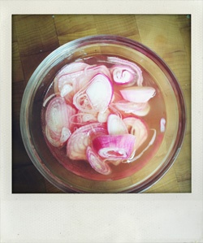

|  |
| --- |
| http://assets.goop.com/temp/10x10.png |

*ingredients*

|  |
| --- |
| http://assets.goop.com/temp/10x10.png |

http://assets.goop.com/temp/issue-break.png

|  |
| --- |
| http://assets.goop.com/temp/10x10.png |

* 1 large shallot, sliced
* 1/2 cup of apple cider vinegar
* teaspoon sugar
* teaspoon salt

|  |
| --- |
| http://assets.goop.com/temp/10x10.png |

http://assets.goop.com/temp/issue-break.png

|  |
| --- |
| http://assets.goop.com/temp/10x10.png |

*preparation*

|  |
| --- |
| http://assets.goop.com/temp/10x10.png |

1.Stir sugar and salt into the apple cider vinegar until dissolved. 

2.Add shallots to the vinegar mixture and let sit overnight. 